PMP Student User Guide

V01.0
17 June 2024

Contents

1. Using the PMP System 3
1.1 Logging in 3
1.2 Student Profile 3
1.3 Viewing your Placement Details 5
2. Support desk 6
3. Mandatory Document Controls 6

Using the PMP System

Logging in
You can access the Placement Management Partnership (PMP) using the URL: https://pmp.tribalsits.com/
PMP uses your university’s Single Sign In (SSO) to manage your access. Only named, individual university-allocated email addresses are permitted.

Log in to https://pmp.tribalsits.com/ with your individual university email address using the same multi-factor authentication (MFA) as you do to access other university applications such as Outlook.
If you have any problems logging in, contact pmp@tribalgroup.com to confirm that your account has been set up using the correct email address. For any other issues logging in, please contact your institution’s IT support.

Student Profile
When you sign in you can see your student profile, which is divided into four sections.
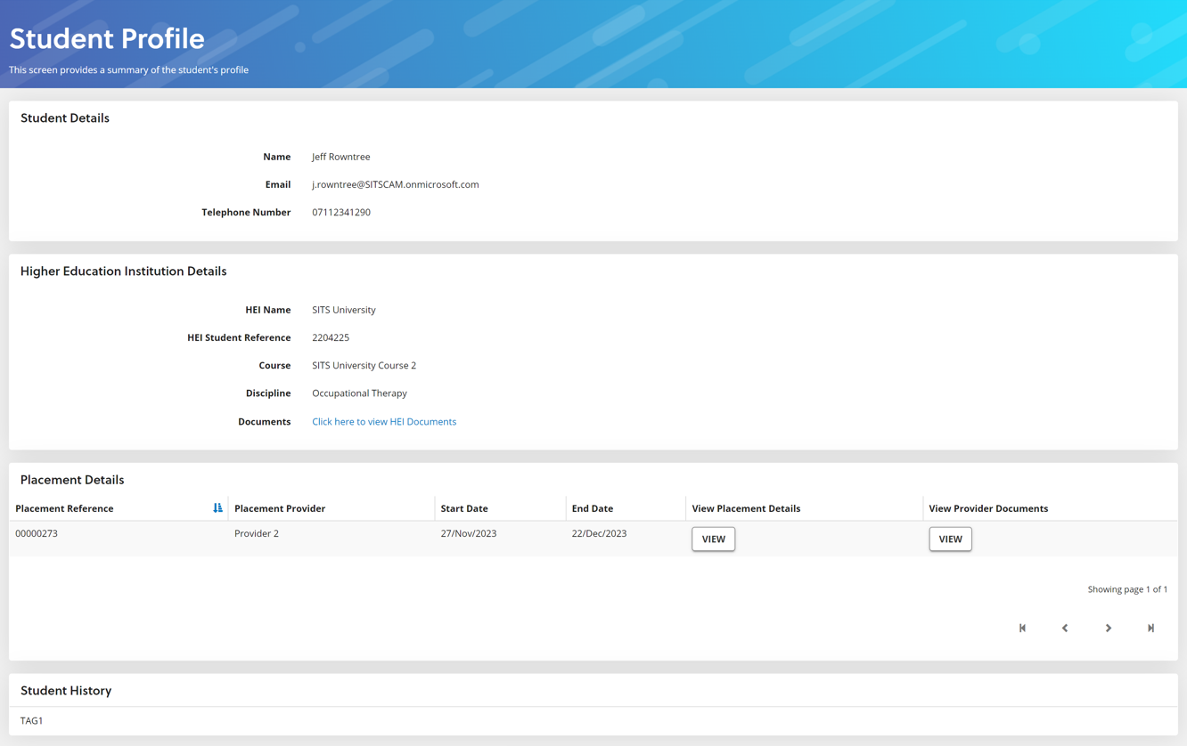

Section 1 – Student details
This shows your name, university email address and telephone number (if provided). If any of these details needs to be amended, please contact your university.

Section 2 – Higher Education Institution (HEI) Details
This shows the below details.
- The university (Higher Education Institution) at which you are studying.
- HEI student reference number.
- The course which you are studying.
- Your course discipline, for example Physiotherapy or Occupational Therapy
- Documents uploaded by your HEI.

Clicking on the Click here to view HEI Documents link brings up a pop up showing relevant any documents your university has provided. Clicking on the link for each document allows you to open, read, or download the document.
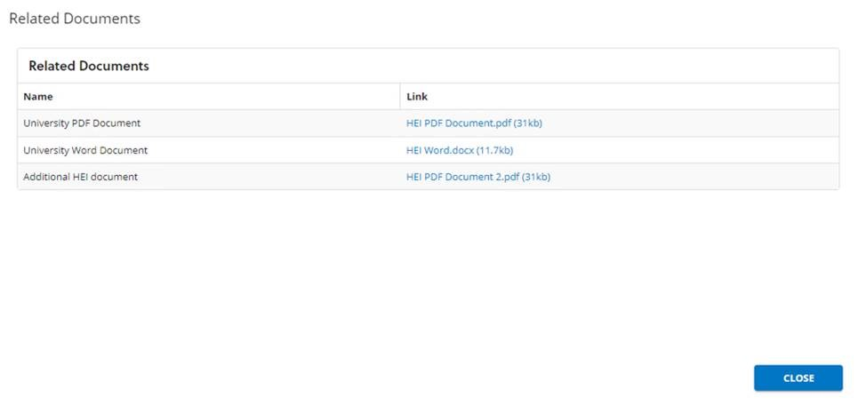

Section 3 – Placement details
Your placement details are shown in this section. This includes details of any previous placements.

Section 4 – Student History
This shows the settings or tags associated with your placements.
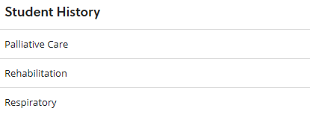

Viewing your Placement Details

You will receive a confirmation email once a placement has been allocated to you.
To view your placement(s) on the system, go to the Placement Details section of your Student Profile. To see more details about your placement, click on the VIEW button at the side of the placement you want to view.
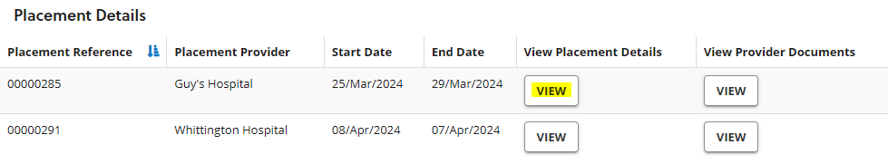

The placement details will be displayed in a pop-up window.
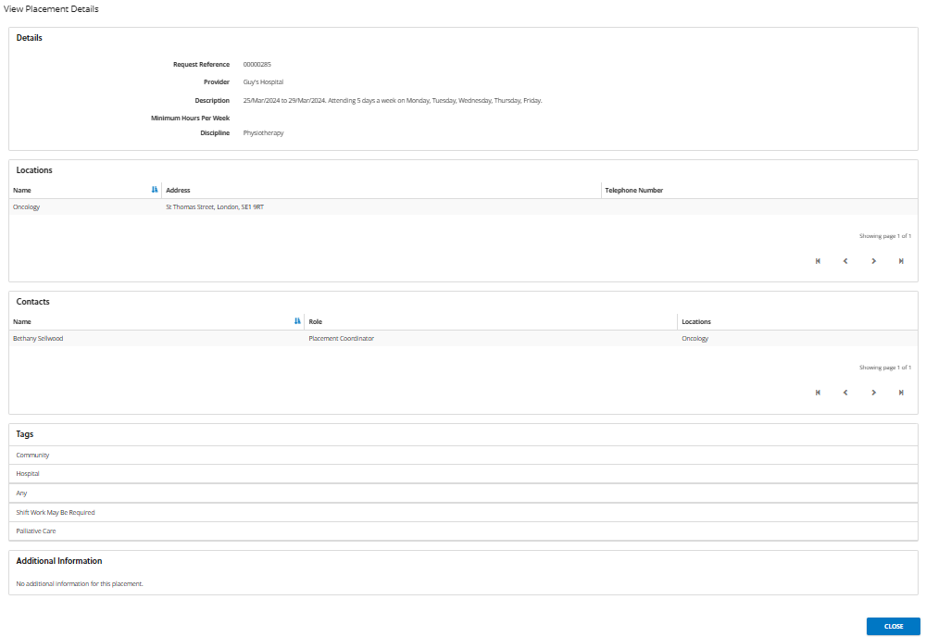

To view any documents that the placement provider has provided, click on View Provider Documents button in the Placement Details section.
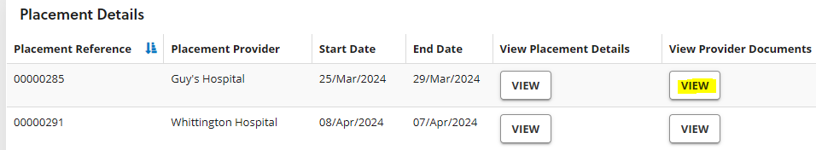

Related documents will be displayed in a pop-up window for you to open, read or download.

Support desk
If you need any support with using the PMP system, please contact the helpdesk on:

Phone: 0844 811 5037
Email: pmp@tribalgroup.com

Opening hours: 9am to 5pm – Monday to Friday (Excluding English Bank Holidays)

PLEASE NOTE: If you have any questions or concerns about your placement suitability, speak to your university.

Mandatory Document Controls
Approval
Document approved by: | Carla Martinho | Head of DMS
Review Requirement | Annual | or sooner if required

Document History
Version Number | Date | Comments | Created by or reviewed and updated by
V00.D01 | 30/04/2024 | Draft - All new screenshots for PMP in SITs. | Gail Fella
V01.0 | 17/06/2024 | Approved | Carla Martinho

Contact Details
All proposals for amendments to this document should be addressed to the following:
Role & Name | Contact Details
Gail Fella | gail.fella@tribalgroup.com

